Multi-Master setup using Kubeadm

We need 4 servers.

1 Ec2 – Haproxy will act as load balancer.

2 Ec2 – Will act as master nodes.

1 Ec2- Will act as worker nodes.

Install and configure HA proxy

Check the status

Edit the configuration file

Reload the services



Check 6443 port is listening



Below needs to be on Master and worker nodes

Check n/w connectivity between all 3 nodes

Disable firewall in all 3 machines

Disable swap in all 3 machines

Let IP tables see bridge traffic

Install Docker

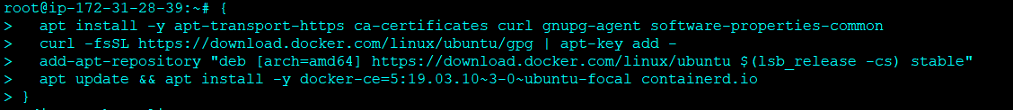

Make the cgroup driver as systemd for container runtime and kubelet

Restart docker

Add repository for k8s

Install kubeadm/kubelet/kubectl

Initialize the cluster in any one of the master nodes

Deploy the calico network on any of the master nodes



Join the worker and additional master nodes

Join the 2nd master nodes

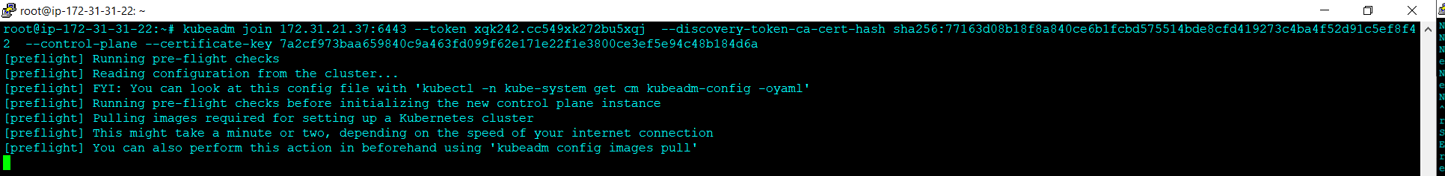

Join the worker nodes

Check cluster status

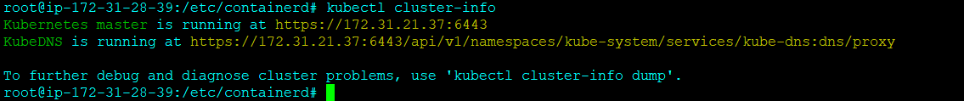

Check the cluster node status. When you have both docker/containerd runtime, docker takes the precedence



Look the HA proxy logs

Check the POD status in

